**Title: Demystifying Subnetting: Unravelling the Digital Neighbourhood**

In the vast landscape of networking, there exists a concept that often bewilders both newcomers and seasoned professionals alike: subnetting. It's like carving out digital neighbourhoods in the immense cityscape of the internet. So, let's embark on a journey to demystify subnetting and shed some light on this vital networking skill.

**What is Subnetting?**

Imagine you're in charge of a sprawling metropolis, and you want to organize it efficiently. You decide to divide it into smaller neighbourhoods to manage resources, utilities, and communication more effectively. This is essentially what subnetting does for computer networks.

In the world of networking, subnetting is the practice of dividing a large network into smaller, more manageable subnetworks, or subnets. It's a way to optimize the use of IP addresses, control traffic, and improve network performance.

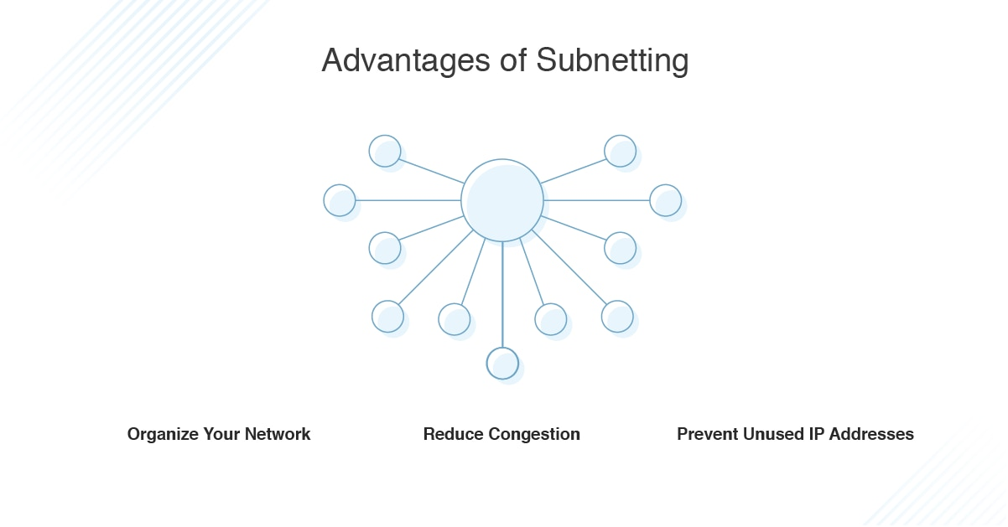

<https://www.dnsstuff.com/wp-content/uploads/2020/02/subnetting-advantages.png>

**The IP Address Magic**

Before we delve deeper, let's talk about IP addresses. They are like the postal addresses of the digital world, allowing devices to communicate over the internet. An IP address is typically a string of numbers (IPv4) or a combination of numbers and letters (IPv6) that identifies a specific device on a network.

IPv4, the most common type of IP address, consists of 32 bits, divided into four groups, each called an octet. These octets are separated by periods, like 192.168.1.1.

**Why Subnetting Matters**

Now, let's put subnetting into context. Think of a large office building with several floors. Each floor might represent a different department: marketing, sales, HR, and so on. Subnetting is like dividing each floor into individual offices. It creates isolated zones within your network for various purposes.

Here's why subnetting matters:

**Efficient IP Address Allocation**

IP addresses are a finite resource, and conserving them is crucial. Subnetting allows you to allocate IP addresses more efficiently by grouping devices that share common characteristics or are located in the same physical area.

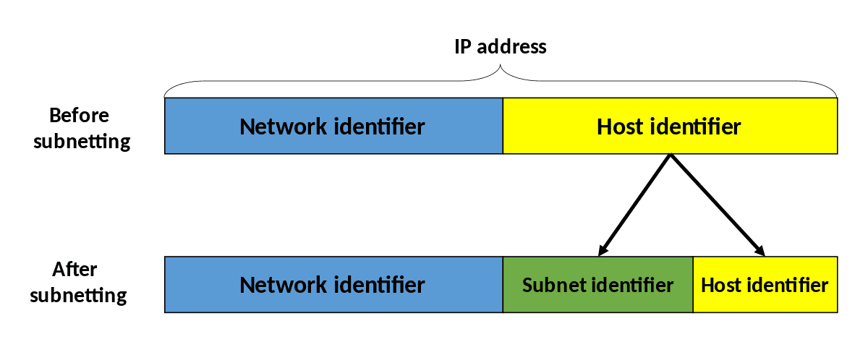

<https://www.lifewire.com/thmb/jhDVaEh3XLkxX2K7LAeisILHpxQ=/1500x0/filters:no_upscale():max_bytes(150000):strip_icc()/1200px-Subnetting_Concept-en.svg-5c3b77b846e0fb0001836aba.png>

**Improved Network Performance**

When you have a large network, it can get congested with too much traffic. Subnetting helps in segmenting the network, reducing unnecessary broadcast traffic, and improving overall performance.

**Enhanced Security**

By creating isolated subnets, you can implement security measures more effectively. It's like having different layers of security within your digital city, making it harder for unauthorized access to spread throughout the network.

**Subnetting in Action**

Let's walk through a simplified example. Imagine you're managing a network for a small business that has two departments: sales and IT.

- Sales: You assign IP addresses in the range 192.168.1.1 to 192.168.1.127.

- IT: You assign IP addresses in the range 192.168.1.128 to 192.168.1.255.

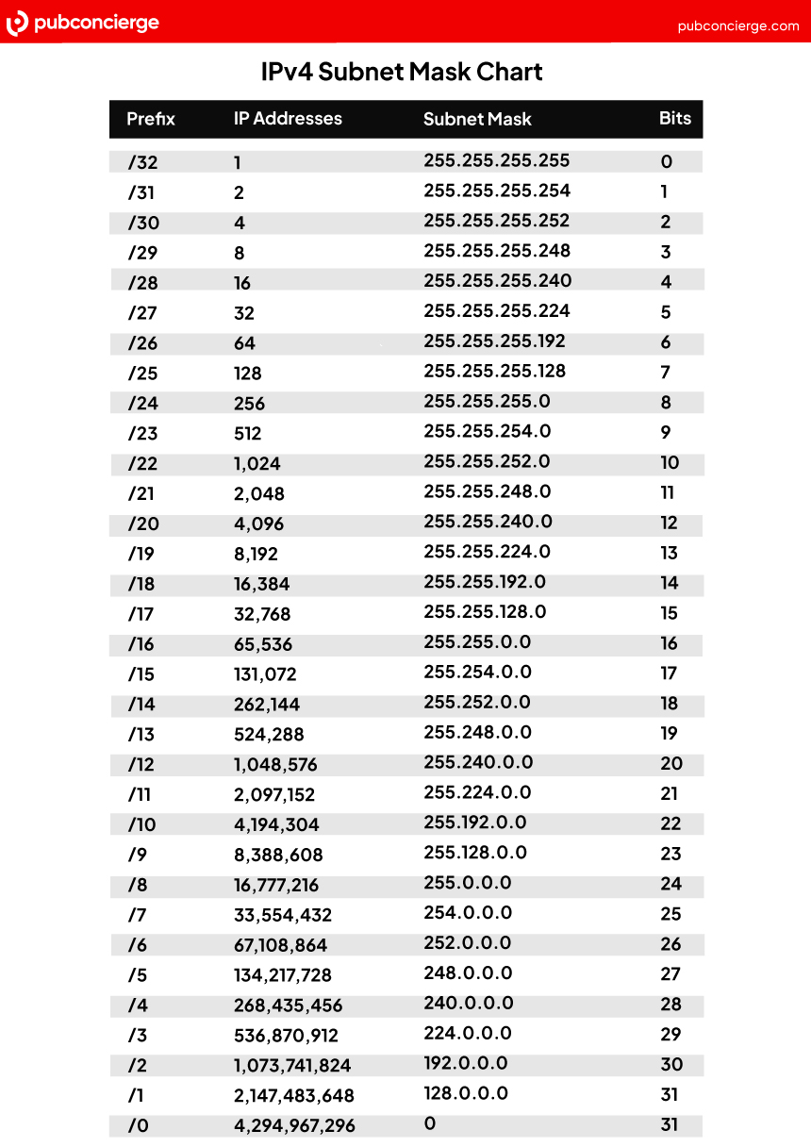

<https://www.pubconcierge.com/blog/wp-content/uploads/2022/07/Pubconcierge-Subnet-Cheat-Sheet.jpg>

Here, you've effectively created two subnets within your network: one for sales and one for IT. Devices in these subnets can communicate with each other, but you can also control their access and permissions separately.

**Subnet Masks**

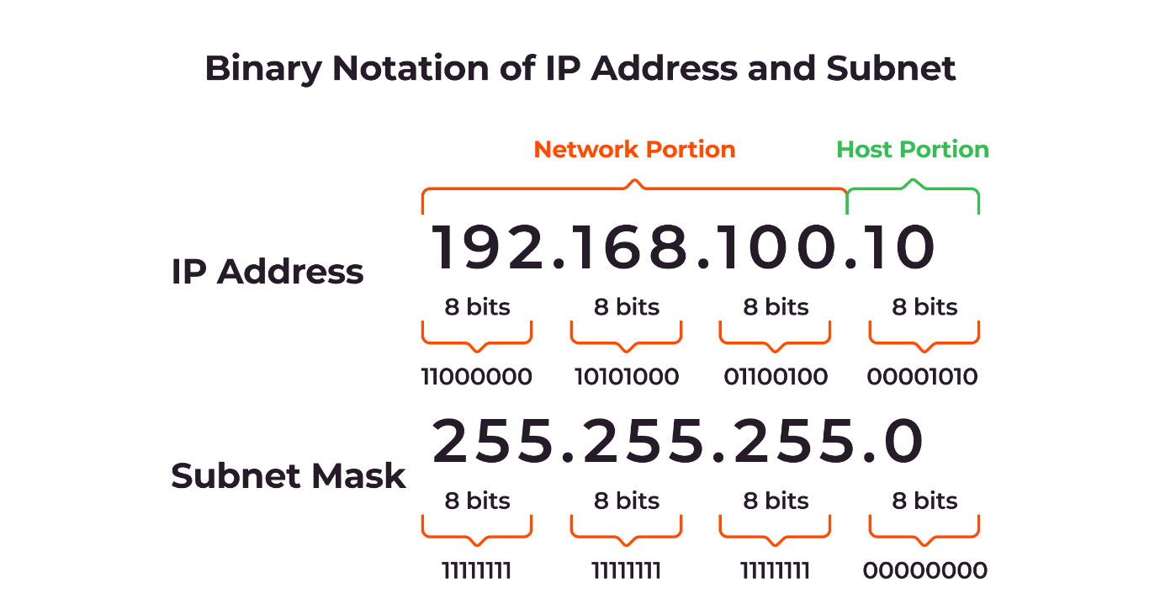

<https://assets.gcore.pro/blog/what-is-a-subnet-how-subnetting-works/what-is-a-subnet-how-subnetting-works-2.png>

Subnetting is not just about dividing IP address ranges; it involves using something called subnet masks. A subnet mask defines the boundaries of a subnet and helps routers determine whether to forward data within the same subnet or send it to another subnet.

For our example, you might use a subnet mask like 255.255.255.0. This mask tells devices that the first three octets (192.168.1) are for the network, and the last octet is for individual devices within that subnet.

**In Conclusion**

Subnetting is the art of creating digital neighbourhoods within your network, bringing order to the chaos of the internet. It's a powerful tool for efficient IP address allocation, improved network performance, and enhanced security.

By understanding the fundamentals of subnetting and subnet masks, you gain the ability to design and manage networks that are not only efficient but also secure. Just like a well-organized city, a well-sub netted network can thrive and flourish in the ever-expanding digital landscape.